Multiple-choice section – choose the correct answer

Question 1 [4.1]

The perimeter of the rectangle below is:

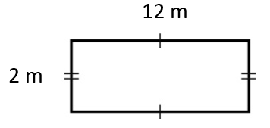

A 48 m B 28 m C 26 m D 14 m

Question 2 [4.1]

The arc length of the shaded sector below, correct to 2 decimal places, is:

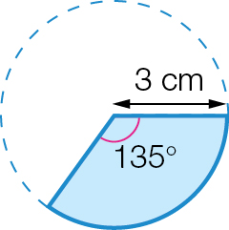

A 3.53 cm B 6 cm C 7.07 cm D 9.42 cm

Question 3 [4.1]

The perimeter of the shaded region shown is:

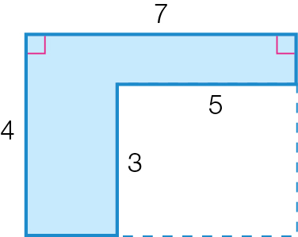

A 22 cm B 20 cm C 19 cm D 11 cm

Question 4 [4.2]

300 mm2 is equivalent to:

A 3 m2 B 30 cm2 C 300 cm2 D 3 cm2

Question 5 [4.2]

The area of the square shown is:

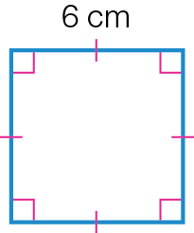

A 36 cm B 12 cm2 C 24 cm2 D 36 cm2

Question 6 [4.2]

The area of this composite shape is:

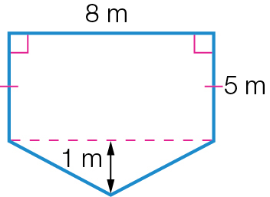

A (8 × 5) + ( × 8 × 1) m2

B (8 × 5) – ( × 8 × 1) m2

C (8 × 5) + (8 × 1)m2

D (2 × 4) + (8 × 2) m2

Question 7 [4.4]

The volume of the following prism is:

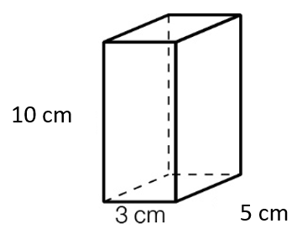

A 18 cm3 B 35 cm3 C 150 cm3 D 250 cm3

Question 8 [4.4]

2 m3 is equivalent to:

A 2 cm3 B 2 000 000 cm3 C 20 000 cm3 D 200 cm3

Multiple-choice results: \_\_\_ / 8

Short answer section

Question 9 4 marks [4.1]

Calculate the perimeter of the following shapes (to 2 decimal places where necessary).

|  |  |
| --- | --- |
| (a)  C:\Users\Maja\AppData\Local\Microsoft\Windows\INetCache\Content.Word\PM2e_09_EB_04_FBT_05.jpg | (b)  C:\Users\Maja\AppData\Local\Microsoft\Windows\INetCache\Content.Word\PM2e_09_EB_04_FBT_05.jpg |

Question 10 4 marks [4.1]

Calculate the perimeter and the area of the following sector, correct to 2 decimal places.

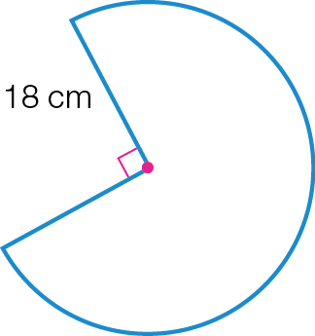

Question 11 2 marks [4.1]

At the start of soccer training, Tina jogs around the soccer ground, which has the rectangular shape with dimensions 74 m by 32 m.

(a) What is the perimeter of the soccer ground?

(b) If Tina jogs around the ground five times, how far has she jogged? Give your answer in kilometres.

Question 12 4 marks [4.2]

Complete the following area conversions.

(a) 8 cm2 = \_\_\_\_\_\_\_\_\_\_\_\_\_\_\_ mm2

(b) 7 m2 = \_\_\_\_\_\_\_\_\_\_\_\_\_\_\_\_\_\_\_\_ cm2

(c) 20 000 cm2 = \_\_\_\_\_\_\_\_\_\_\_\_\_\_\_ m2

(d) 0.9 km2 = \_\_\_\_\_\_\_\_\_\_\_\_\_\_\_ m2

Question 13 6 marks [4.2]

Find the area of the following composite shapes (to 2 decimal places where necessary).

|  |  |
| --- | --- |
| (a) PM2e_09_EB_04_FBT_07 | (b) PM2e_09_EB_04_FBT_08 |

Question 14 4 marks [4.3]

Find the surface area of the following solids (to 2 decimal places where necessary).

|  |  |
| --- | --- |
| (a) PM2e_09_EB_04_FBT_09 | (b) PM2e_09_EB_04_FBT_10 |

Question 15 6 marks [4.4]

For the following solids, find correct to 2 decimal places:

|  |  |
| --- | --- |
| **(i)** | **(ii)** |

(a) the base area

(b) the volume

(c) the capacity in litres

Short answer results: \_\_\_ / 30

Extended answer section

Question 16 8 marks [4.1, 4.2, 4.4]

James has decided to retile the bottom floor of the swimming pool in his backyard with the dimensions outlined in the diagram below.

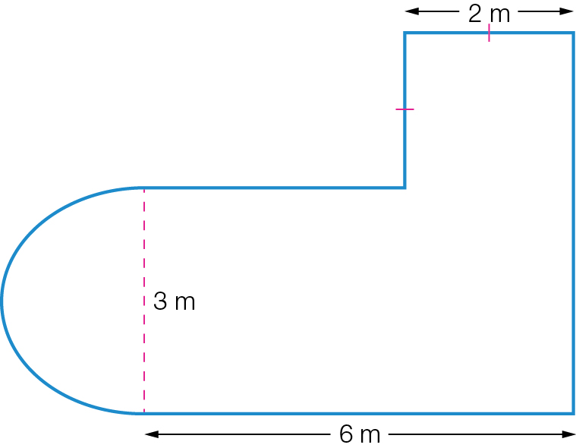

(a) Find the perimeter of the pool, correct to 2 decimal places.

(b) Find the area of the pool that needs to be tiled, correct to 2 decimal places.

(c) If the tiles cost $52 per square metre, how much will they cost James for the entire pool? Round your answer to the nearest dollar.

(d) If the whole pool is 1.1 m deep, how many kilolitres of water are needed to fill the pool? Give your answer correct to 1 decimal place.

Question 17 7 marks [4.3, 4.4]

Milk is transported from a dairy farm to a processing plant in the large ‘tank trucks’. The tank on the truck is a large cylinder that has a diameter of 2.1 m and a height of 9.5 m.

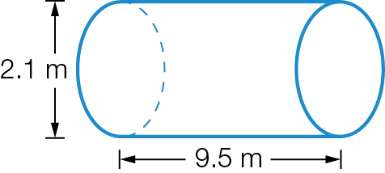

(a) Calculate the volume of the tank on the truck (in cubic metres to 3 decimal places).

(b) Convert your answer to **(a)** to litres.

At the processing plant, the milk is transferred into small tanks. These tanks are rectangular in shape, with dimensions of 1.3 m by 95 cm by 80 cm.

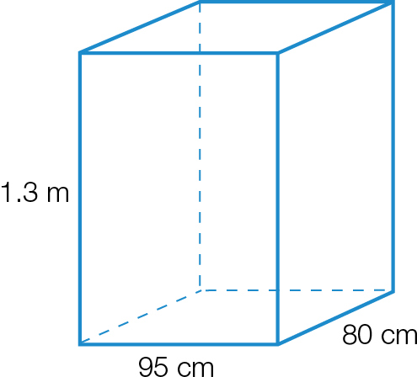

(c) Calculate the volume of this smaller tank in in cubic centimetres.

(d) Convert your answer to **(c)** to litres.

(e) Using your answers from parts **(b)** and **(d)**, calculate the number of the smaller tanks at the processing plant that could be filled from one large tank truckload.

Extended answer results: \_\_\_ / 15

TOTAL test results: \_\_\_ / 53